
AML Instruments Ltd T: 01522 789375
Eco One, Highcliffe Business Park E: sales@amlinstruments.co.uk
The Cliff, Lincoln W: www.amlinstruments.co.uk
Lincolnshire
LN1 2WE

Measuring Success

SNOL 1100°C Laboratory Furnaces

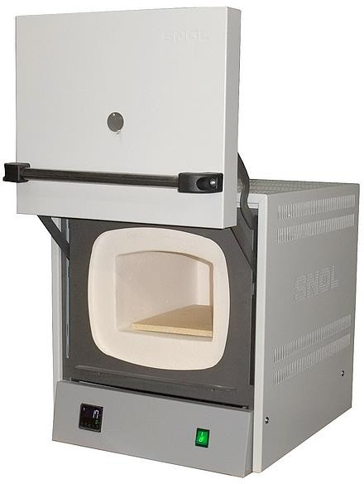


The Fibre Muffle 1100 series from AML Instruments are precision laboratory electric muffle furnaces, with a counter balanced lift-up door, for use up to 1100°C.
- Lift-up door for efficient use of workspace and greater safety.
- Good stability and uniformity.
- Fast heating and cooling time due to low thermal mass construction.
- Low power consumption for reduced running costs and energy savings.
- Serviceable design and long-term support & repairs.
- Many customisations and options on short lead-times.
- Available from AML’s
UK stock for fast delivery.
Designed for materials testing, heat treatment, ceramic samples firing and ashing (models with chimney), they’re used in laboratories, educational institutions, workshops, and in industry for thermal processing.
The chambers are made of high thermal efficiency vacuum- formed ceramic fibre, with heating elements embedded in the sides, top and bottom of the chamber, providing heat from 4 directions. A hard-wearing ceramic tile protects the fibre base from wear.
An Omron E5CC digital PID temperature controller is fitted as standard and provides precise temperature control with good stability and minimal over-shoot. Other options are available (see page 5).
A chimney, fitted to the rear of the furnace, is recommended for processes producing fumes or giving off carbon (e.g. ashing or burn-off operations). A chimney is included as standard on larger models (see the following pages).
Independent over-temperature protection is available and is recommended if the furnace will be run while unattended (e.g. overnight); to meet Health & Safety and some insurers’ requirements. Adjustable over-temperature protection (OTP2) can be set to a temperature to protect load placed in the chamber, in addition to the furnace itself. Adjustable over-temperature protection is included as standard from AML on larger models (see the following pages).
The sustainable design means all parts are accessible, serviceable and replaceable should the need arise. AML Instruments has offered long-term product support on SNOL furnaces for over 15 years, stocking a wide range of spares and accessories at our factory in the UK.
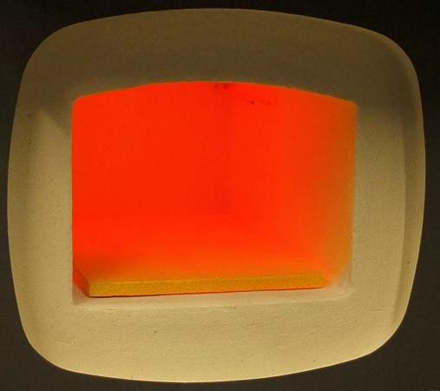
Our furnaces are available with optional UKAS (ISO 17025) calibration of the temperature control system, and we also offer multi-point thermal surveys of the chamber volume.
AML Instruments offers models customised to meet AMS 2750G (aerospace & automotive heat treatment specification), complete with UKAS (ISO 17025) calibration and thermal survey meeting NADCAP requirements. For customisation to this specification or others please contact us.
A metal tray is optionally available for each model and is recommended to protect the furnace from spills or debris produced by some processes.

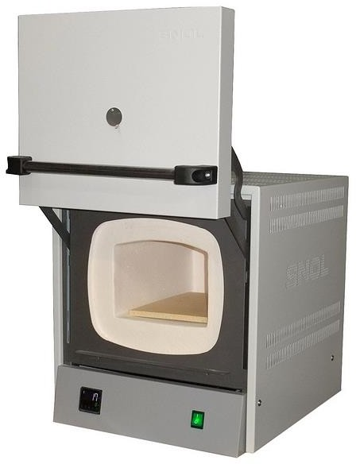
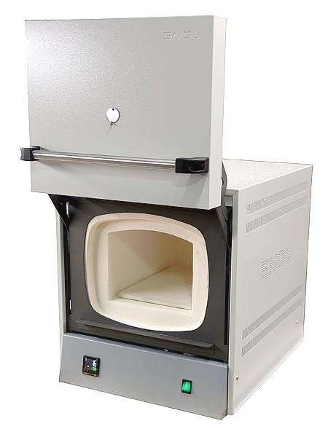
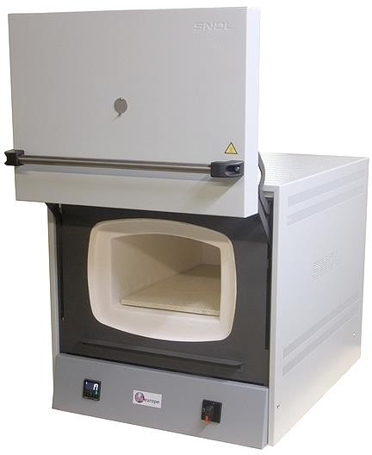
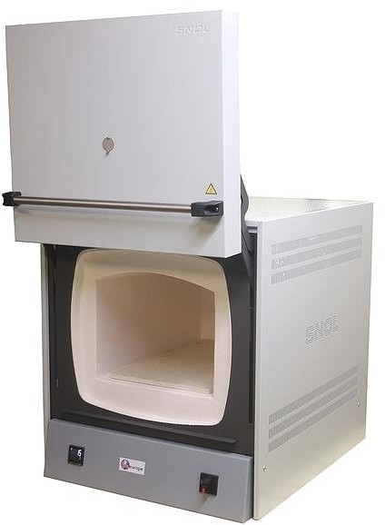
SNOL /1100 Fibre Muffle series
3/1100
8.2/1100
13/1100
(Relative model sizes between images are not exact.)

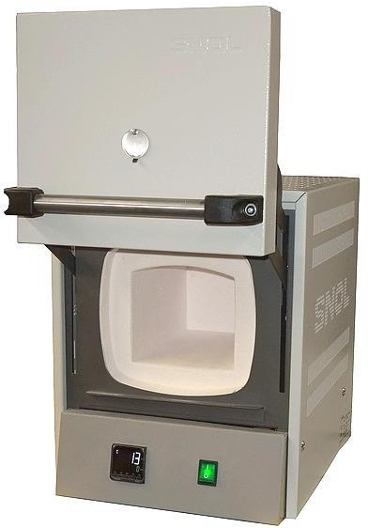
Smaller Models

22/1100
39/1100


These units are manufactured in the EU by SnolTherm (Umega Group, AB) to AML Instruments Ltd’s specification. Final manufacturing, testing, localisation, customisations, addition of options and after-sale service are performed in the UK by AML Instruments Ltd.

SNOL 1100°C Laboratory Furnaces from AML Instruments

Smaller Models

Model  AML Stock Code | Capacity*  (Chamber WxDxH in mm) | External Size  (Body WxDxH in mm) | Voltage / Power / Connector | Price
SNOL 3/1100 LHM01  FCESNOL3/1100LHM01 | 3 Litres  125 x 200 x 115 | 340 x 470 x 430 | 230Vac / 1.8kW / UK 13A Plug | £ 1,620
SNOL 8.2/1100 LHM01  FCESNOL8/1100LHM01 | 8.2 Litres  200 x 300 x 133 | 440 x 620 x 510 | 230Vac / 1.8kW / UK 13A Plug | £ 1,780
SNOL 8.2/1100 LHM01 - with natural chimney & over-temperature protection (OTP2)  FCESNOL8/1100LHM01-2 A build with these options is usually available from stock or within 1 week. |  |  |  | £ 2,070
SNOL 13/1100 LHM01  FCESNOL13/1100LHM01 | 13 Litres  225 x 360 x 180 | 500 x 700 x 550 | 230Vac / 1.8kW / UK 13A Plug | £ 2,280
SNOL 13/1100 LHM01 - with natural chimney & over-temperature protection (OTP2)  FCESNOL13/1100LHM01-2 A build with these options is usually available from stock or within 1 week. |  |  |  | £ 2,570

Main Options | Default | Optional
Chimney : | None | Natural Convection  +£120 | Fan-Assisted  +£320 | Natural &  OTP 2  +£290 | Fan &  OTP 2  +£490
Over-Temperature  Protection : | None | OTP 1  (Non-adjustable)  +£170 | OTP 2  (Adjustable)  +£270 | Natural &  OTP 2  +£290 | Fan &  OTP 2  +£490
Additional options and further details are listed on the following pages.

Larger Models

Model  AML Stock Code | Capacity*  (Chamber WxDxH in mm) | External Size  (Body WxDxH in mm) | Voltage / Power / Connector | Price
SNOL 22/1100 LHM01  FCESNOL22/1100LHM01 | 22 Litres  275 x 500 x 155 | 600 x 890 x 610 | 230Vac / 3kW / Blue Round 16A Plug | £ 3,240
SNOL 39/1100 LHM01  FCESNOL39/1100LHM01 | 39 Litres  315 x 515 x 225 | 650 x 900 x 740 | 400Vac (3P+N) / 6kW  Red Round 16A Plug | £ 4,180

Main Options | Fitted as Standard by AML | Optional
Chimney : | Natural Convection | Fan-Assisted  +£180 | None  -£0
Over-Temperature  Protection : | OTP 2 (Adjustable) | None  -£80
Additional options and further details are listed on the following pages.
Notes:
*At least 1/10th of the chamber dimensions should be left unused on each side. External Size not including optional chimney (see dimensions on Page 6).
See page 9 for Further Specifications: heating & cooling times, weights, additional dimensions.
The temperature rating of 1100°C is a ‘continuous use’ rating (a ‘short-term use’ rating is not offered).
If used below 200°C these units (especially larger models) may over-shoot the set temperature, depending on load, with the standard control terms.
WxDxH = Width (left↔right) x Depth (front↔back) x Height (top↔bottom).
Connector: UK 13A = BS1363. Others = IEC60309. Operating environment ambient temperature: 5 to 40°C. It is generally recommended furnaces are under an exhaust ventilation hood, or similar, for many processes.

Temperature Controller options for furnaces
1/16 DIN size (~48x48mm) digital PID temperature controllers, with Run/Stop (Auto/Off) modes and settable heating ramp rate. With 1°C display resolution and featuring Autotune which can be used to optimise the control terms for the load, but which is not necessary for most applications. Optional Programmer models allow advanced timed programs (profiles) to be configured (see next page).
Other instruments can also be fitted to order, providing additional options, such as audible alarms, remote communications (RS-485 etc) and data logging / recording. Please contact us for further details.

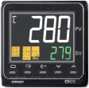 |  | 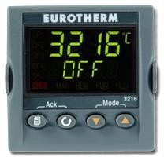 | Eurotherm 3216 Programmer,  1 Program, 8 Segments
 |  |  | Optional at extra cost. +£430
 |  |  | (Segments as Ramp+Dwell pairs)
Eurotherm 3216 Programmer,
5 Program, 8 Segments each
Omron E5CC |  | Eurotherm 3216 | Eurotherm 3216 Programmer,  5 Program, 8 Segments each
( Fitted as standard ) |  | Optional at extra cost. +£320 | Optional at extra cost. +£540
Basic Timed Program: Ramp, Dwell, Stop. |  | Basic Timed Program: Ramp, Dwell, Stop. | (Segments as Ramp+Dwell pairs)

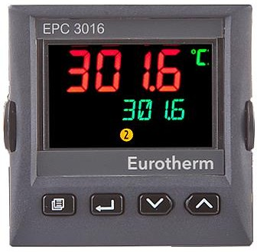 | 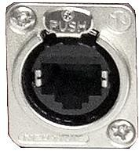
Eurotherm EPC3016 Programmer, 1 Program, 8 Segments  Optional at extra cost. +£430 | Eurotherm EPC3016 Programmer, with RJ45 Ethernet PC Network Port  Optional (when OTP is also fitted) at extra cost:  1 Program, 8 Segments +£590  10 Program, 24 Segments each +£690  Connection to a laptop or PC network via Ethernet RJ45 port on front panel. Includes PC software for easier creation, editing and backup of timed programs.
Eurotherm EPC3016 Programmer, 10 Program, 24 Segments each
Optional at extra cost. +£540

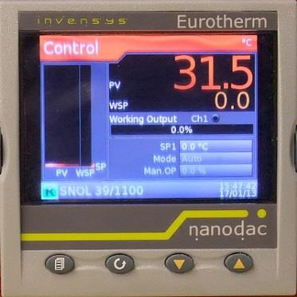 | 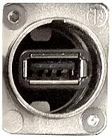 |  | 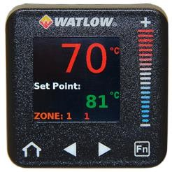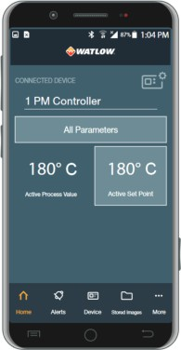
Eurotherm nanodac Recorder, 1/4 DIN, with RJ45 Ethernet PC Network Port, USB data transfer, Programmer option  Contact us for full details and pricing. |  |  | Watlow PM Plus Programmer, 4 Programs, 10 Segments each,  with Bluetooth for wireless phone app connection  Optional (when OTP is also fitted) at extra cost.  +£590 Contact us for full details.

Basic Timed Program
Temperature °C
Temperature °C

Set Point
Eurotherm 3216 - 8 Segment (4 Ramp+Dwell Pairs)

Ramp

Examples of the timed programs:
Dwell
e.g. 60min
Stop

Eurotherm EPC3016 - 8 or 24 Segments
R1 D1 R2
D2
R3 D3 R4
D4 Stop
S0 S1 S2
S3
S4 S5
S6
S7
S8 S9 S10 S11 S12 End
Temperature °C

Over-temperature Protection options for furnaces
By default, AML offers the smaller models without over-temperature protection as a product to remain competitive with equivalent models from other suppliers. Adjustable over-temperature protection (OTP2) is included as standard by AML on larger models (see page 3). Provided the furnace is not left unattended (e.g. overnight), operation without over-temperature protection is acceptable. However, the Health and Safety Directive mandates, and insurer’s often require, that where heat treatment equipment is left unattended they must have independent over-temperature protection fitted. (Prices on Page 3.)

OTP 1  (Non- adjustable) | An internally fitted self-resetting temperature limit controller, which users cannot access or change the temperature setting. Protects the furnace from exceeding its maximum safe temperature. (Not offered on Larger Models, 22/1100 or 39/1100, see OTP 2.)
OTP 2  (Adjustable) | A digital temperature limit controller mounted in the front panel. Displays its temperature reading and can be set by the user to protect their load from exceeding their desired temperature. If the furnace temperature exceeds the temperature set on the over- temperature protection controller, the furnace will be prevented from heating until the user resets the over-temperature protection controller, by pressing a button.

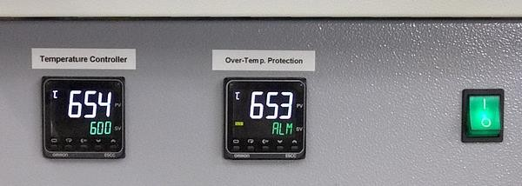
An example of the standard E5CC Temperature Controller and OTP 2 (Over-Temp.
Protection). ‘ALM’ flashes on the display when over temperature.

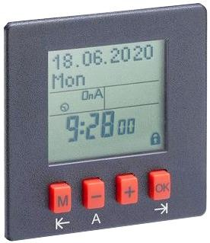
7 Day Timer options for furnaces +£290
A timer can be fitted to the turn on the controller at a specific time. The controller will then run at its last setting. Featuring: Daily and weekly program, Manual override, Fully automatic daylight saving time.

Chimney options
Highly recommend for any process giving off vapour, fumes or carbon. Fitted at the rear. They can also provide occasional access for thermocouples* etc. AML’s construction of the casing is all stainless steel with a ceramic tube, offering long term resistance to corrosion and degradation. Its design helps contain any condensing residue or larger soot debris that may be exhausted from the chamber and allow easy access (4 screws) for cleaning out when necessary. (Prices on Page 3.)

Natural Convection Chimney - Air is drawn through chamber, out through a ceramic tube and up the stainless-steel chimney casing by natural convection.
Fan-assisted Chimney - A greater amount of air is drawn through chamber, out through a ceramic tube and up the stainless-steel chimney casing. Air is forced up the chimney casing by a fan blower at the base, increasing the air draw.

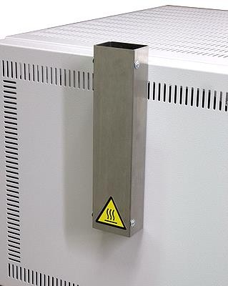
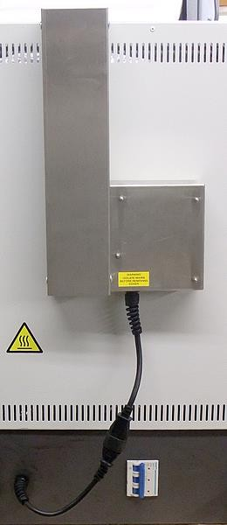
Natural Convection Chimney
Fan-assisted Chimney

The cross section of the Natural Convection Chimney casing is 60x40mm. The cross section of the Fan-assisted Chimney casing is 80x60mm.

A suitable fume extraction system or fume cupboard is also required. If using a small extraction hood or tube directly above the chimney, we recommend a few inches of space are left to allow a mixture of ambient air and chimney air to be drawing into the extractor. Also consider some fumes may escape around the door or if it is opened while hot. If the chimney is no longer needed, it can be blocked with suitable high temperature insulation wool (a small amount is supplied).

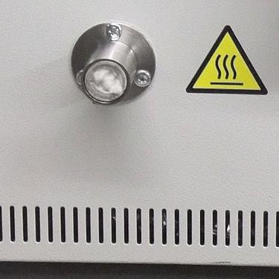
Cable Entry Port option +£180
A 15mm inside diameter ceramic tube at the rear into the chamber for regularly putting in thermocouples* or other sensor cables.
Suitable high temperature rated material is provided to block the Entry Port. Flanges and objects passing through the Entry Port may get hot and conduct heat outside the chamber. Excessive thermal loading or insufficient insulation in the entry port can have a negative effect on thermal uniformity in the chamber. Ceramic dimensions may vary slightly.
*Thermocouples and metal objects passing into the chamber from outside must be suitably earthed and should be fitted by a suitably qualified person.

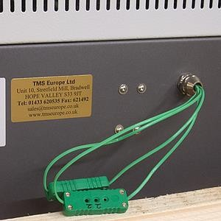
Accessible Thermocouple Connections option +£60
We can fit accessible thermocouple connections (at the rear) to save time with regular calibrations.
Consisting of inline miniature size thermocouple connectors. For use by a suitably qualified person, allowing direct electrical injection onto the instrument(s) sensor input. Units with OTP 2 will have connections for both systems when this option is ordered.

Calibration of furnace systems options

UKAS calibration of instrument(s) and thermocouple(s), as a system, at your choice of temperature(s) between 300 and 1100°C. A calibration certificate is issued reporting the tested system’s measurement at each temperature. This calibration will be carried out in our laboratory prior to fitting into the furnace. The typical lead-time is 4 - 10 working days. Fast turn-around may be available at additional cost. We can also provide on-site calibration and thermal surveys at additional cost.

No. of Specified Temperature Points | Control System Only | Control & OTP 2 Systems
1 | £204 | £247
2 | £257 | £300
3 | £295 | £338
4 | £316 | £359
5 | £354 | £396

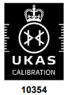
AML Instruments Ltd is a UKAS accredited calibration laboratory No. 10354. We are ISO 17025 accredited for calibration on site and in our laboratory, as defined in our Schedule Of Accreditation (see https://www.ukas.com/wp-content/uploads/schedule_uploads/00001/10354Calibration-Multiple.pdf).

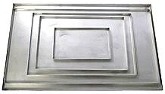
Trays accessories for /1100 furnaces
Metal trays are optionally available for all models, manufactured from stainless steel with a maximum temperature of 1100°C.
Note that these trays are liable to thermal distortion and degradation under the maximum temperature and so are considered a consumable item. Lower heating rates and temperatures will result in less distortion and slower aging.

For Model | Dimensions (WxDxH) | AML Stock Code | Price
SNOL 3/1100 LHM01 | 105 x 180 x 10 mm | FCESNOL3/1100TRAY | £40
SNOL 8.2/1100 LHM01 | 180 x 280 x 10 mm | FCESNOL8/1100TRAY | £60
SNOL 13/1100 LHM01 | 210 x 330 x 10 mm | FCESNOL13/1100TRAY | £70
SNOL 22/1100 LHM01 | 250 x 450 x 10 mm | FCESNOL22/1100TRAY | £80
SNOL 39/1100 LHM01 | 290 x 470 x 10 mm | FCESNOL39/1100TRAY | £90

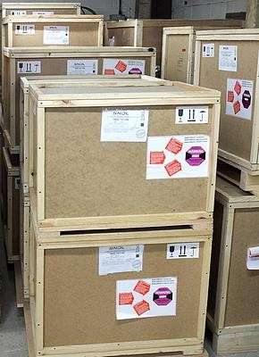
AML typically holds 14 standard builds of SNOL furnaces and ovens, ready to ship or finalised within a week, in stock at our factory and warehouse (near Sheffield, UK).
With additional customisations and options within 2 weeks. Viewing and demonstration is available by arrangement.
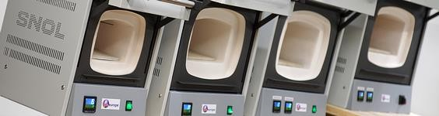

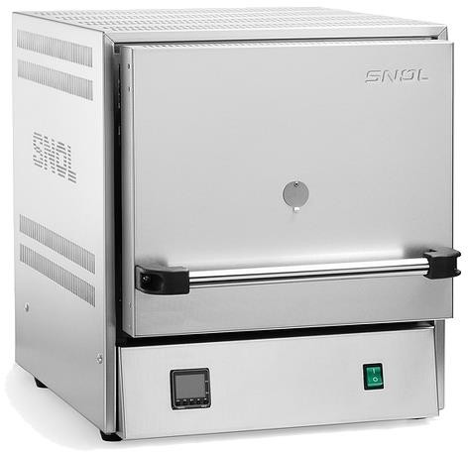
Other options

The range is also available with stainless steel exterior (pictured). The lead time is typically 6 – 8 week and the price of the unit and some options are higher. Please contact us for a quote.

We may be able to assist with other bespoke requirements, please contact us for further details.
Whilst most models are normally available from UK stock for fast delivery, options normally take longer, <1 week for most, but up to 2 weeks for some. Please contact us for a quote with current lead-times.
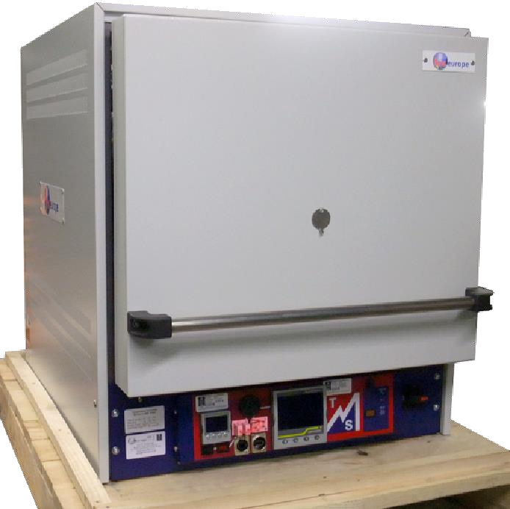
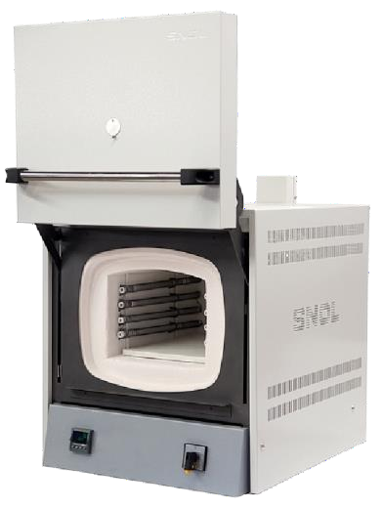
We manufacture enhanced versions of these furnaces meeting AMS 2750G and Nadcap compliant. Complete with calibration, under our ISO 17025 (UKAS) accreditation, and thermally surveyed before leaving our factory. With thermal uniformity up to Furnace Class 1 ( ±3°C ) and Instrumentation Types up to ‘A’.
We offer higher temperature models, for use up to 1300°C.
Our stock SNOL 10/1300 LHM01 includes over-temperature protection and chimney as standard.

Delivery & Shipping

These units are shipped as a palletised wooden crate, on a courier service which is normally next-day for much of the UK.

Destination | Price | Typical Transit Time
UK Mainland (England, Wales, Scottish Lowlands) | £95 | 1-2 days
UK Scottish Highlands, Ilse of Wight | £130 | 1-3 days
UK Northern Ireland & Republic of Ireland | £175 | 1-3 days
Other destinations (including other UK coastal islands) | Please contact us for a quote.
Collection from our factory (Derbyshire, UK) | £30 (Weekdays, by arrangement.)

Further Specification | 3/1100 | 8.2/1100 | 13/1100 | 22/1100 | 39/1100
Heating Time :  (To 1100°C, no load, no options. Approx.) | 45min | 50min | 50min | 55min | 55min
Height with Door Open : | 650mm | 800mm | 900mm | 1000mm | 1200mm
Ceramic Tile Dimensions : | 175x110mm | 260x175mm | 300x210mm | 490x260mm | 490x300mm
Max Chamber Load Weight ¹ : | 2.2kg | 5kg | 6.5kg | 13.5kg | 14.5kg
Base Unit Weight ² : | 18kg | 28kg | 38kg | 58kg | 75kg
Packaged Transport Weight ² : | 27kg | 36kg | 54kg | 83kg | 118kg
1 Approximately. Non-concentrated, e.g. on the ceramic tile. 2 Weights exclude options.

Cooling Rate Example: SNOL 13/1100 without chimney

Time, Hours | 0.0 | 0.5 | 1.0 | 1.5 | 2.0 | 2.5 | 3.0 | 3.5 | 4.0 | 4.5 | 5.0
Temp., °C | 1100 | 840 | 680 | 540 | 480 | 400 | 340 | 290 | 250 | 210 | 180
Rate, °C/hour | - | 520 | 320 | 280 | 120 | 160 | 120 | 100 | 80 | 80 | 60
Rate, °C/min | - | 8.7 | 5.4 | 4.7 | 2 | 2.7 | 2 | 1.7 | 1.4 | 1.4 | 1
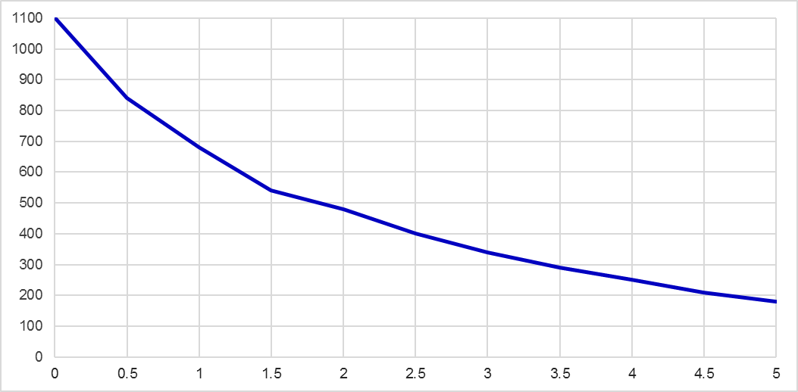
The default E5CC controller can have a ramp rate set at a specific rate per hour, which applies to both heating and cooling. By request (when ordering) the settings can be unlinked, so the cooling ramp rate can be set differently from the heating rate.
Note that the control of cooling is only to limit the rate at which it falls, it cannot increase the speed beyond its natural rate.

Operation & Preparation Notes
- Heating is stopped (elements are electrically isolated) whilst the door is opened (for safety).
- Before first use of the new furnace a ‘burn-off’ procedure must be performed which takes 5-8 hours to cure the fibre insulation. (We typically avoid doing this before transport, since the fibre become more fragile after it has cured and could be at greater risk of transport damage or vibration wear.)
- The low thermal mass insulation fibre of the muffle chamber provides excellent energy efficiently, but it can be worn away if repeatedly rubbed by abrasive items or dented by pointed objects or excessive force. The ceramic hearth tile is intended to stay in the chamber to protect the base against wear. So it shouldn’t be regularly slid in and out like a tray, as this may wear the fibre.
See our video showing the lift-up door style and default controller operation : https://youtu.be/eH2t971vlJc

After Sales Service & Warranty

AML Instruments has been stocking and selling the SNOL range since 2008. We hold UK stock of a wide range of spares and accessories and can offer service and repairs at our factory if required at a later date. On-site service and basic repairs may be available subject to location and the nature of the repair. We also offer a range of on-site calibration services, see our website or contact us for more details.

Each unit has a 1 year return to base warranty from the date of purchase from AML Instruments and covers normal use of the unit in accordance with its instruction manual. It does not cover excessive ‘wear and tear’ to the soft fibre muffle or damage caused by careless use of the spring assisted door.

On receipt of the unit it is important to check for any transport damage and report it to AML Instruments and note it on the carrier’s paperwork. It is recommended to keep the original wooden packaging in case the unit ever needs returning.

Under the warranty any manufacturing defects will be rectified by AML Instruments as the agent of the manufacturer at no charge. ‘Return to base’ means the customer is responsible for return of the unit to AML Instruments’s site (Derbyshire, UK) for assessment with a view to repairing under warranty. Or, if necessary, we can provide collection at a cost, provided the unit is suitably packaged. For any work performed that is solely covered by the warranty AML Instruments will provide return shipment of the unit within the UK and Republic of Ireland at no charge. Whilst AML Instruments stocks a range of spares and aims to resolve any warranty repairs quickly, typically within 3 – 8 working days, the warranty does not guarantee this or any provision of a loan unit while the customer’s unit is with us.

AML Instruments Ltd is a UKAS accredited calibration laboratory No. 10354.
We are accredited for calibration on site and in our laboratory, as defined in our Schedule Of Accreditation (see https://www.ukas.com/wp-content/uploads/schedule_uploads/00001/10354Calibration-Multiple.pdf).

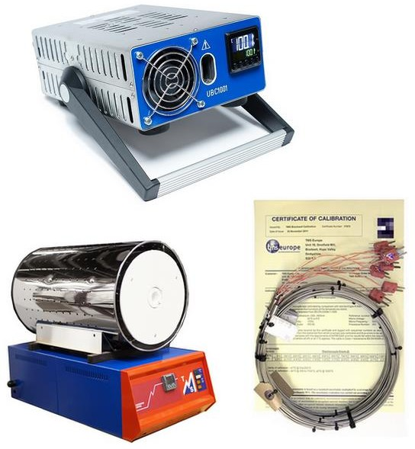
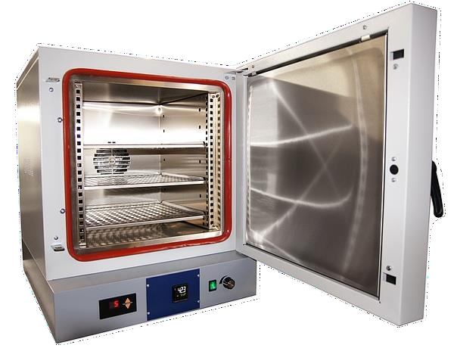
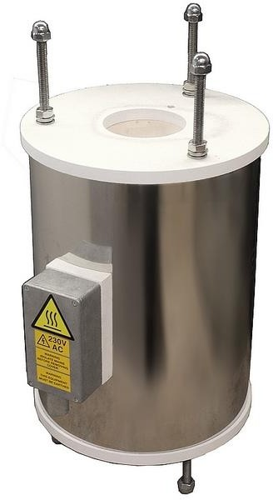
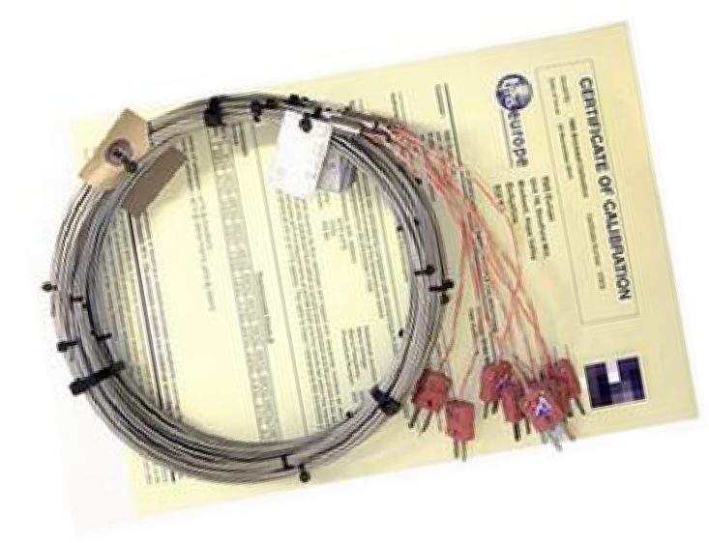
Part of a range of thermal solutions from AML Instruments

